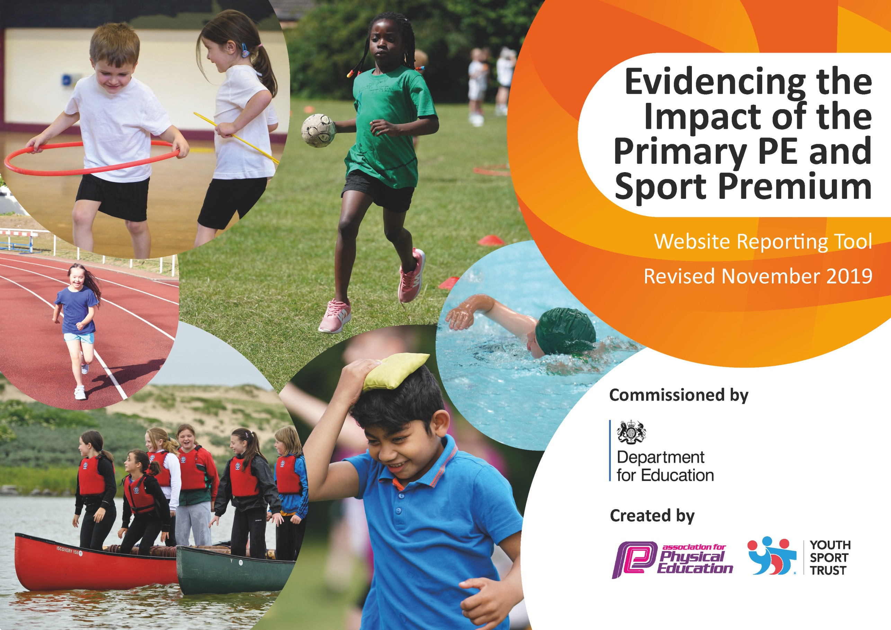
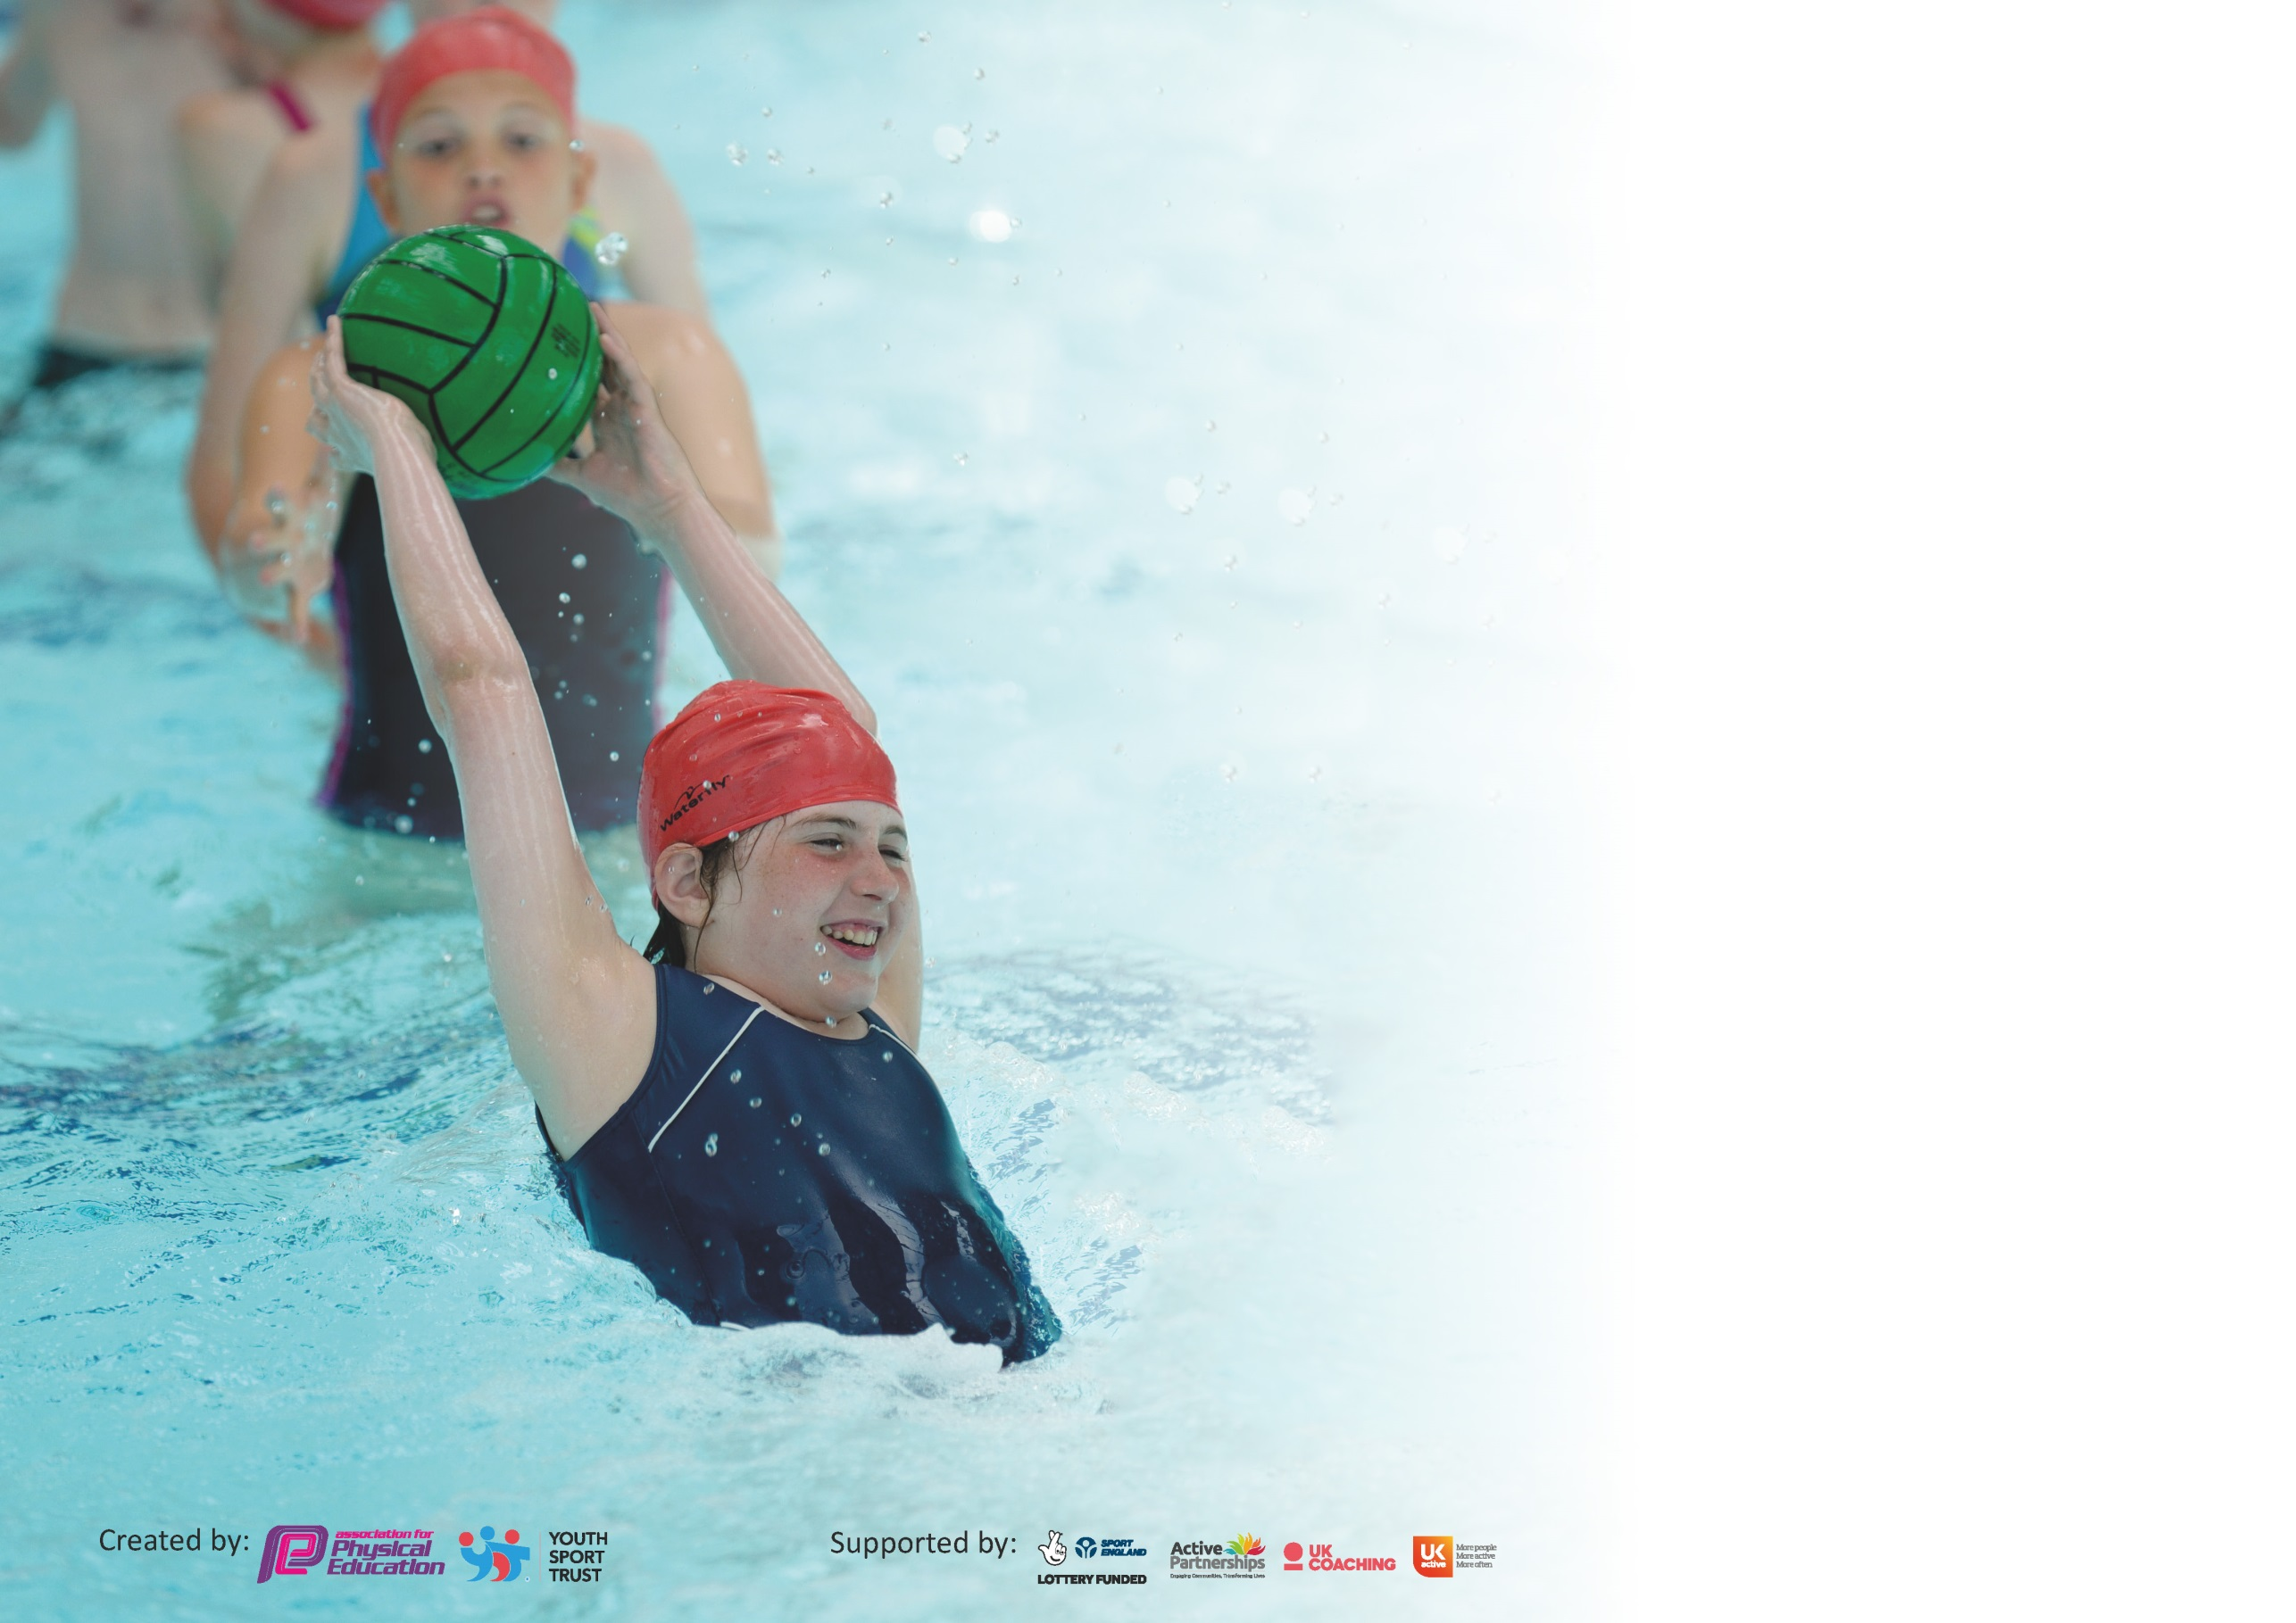

It is important that your grant is used effectively and based on school need. The Education Inspection Framework (Ofsted 2019 p64) makes clear there will be a focus on ‘whether leaders and those responsible for governors all understand their respective roles and perform these in a way that enhances the effectiveness of the school’.

Under the Quality of Education criteria (p41) inspectors consider the extent to which schools can articulate their curriculum (INTENT), construct their curriculum (IMPLEMENTATION) and demonstrate the outcomes which result (IMPACT).

To assist schools with common transferable language this template has been developed to utilise the same three headings which should make your plans easily transferable between working documents.

Schools must use the funding to make additional and sustainable improvements to the quality of Physical Education, School Sport and Physical Activity (PESSPA) they offer. This means that you should
use the Primary PE and Sport Premium to:

- Develop or add to the PESSPA activities that your school already offer
- Build capacity and capability within the school to ensure that improvements made now will benefit pupils joining the school in future years

Please visit gov.uk for the revised DfE guidance including the 5 key indicators across which schools should demonstrate an improvement. This document will help you to review your provision and to report your spend. DfE encourages schools to use this template as an effective way of meeting the reporting requirements of the Primary PE and Sport Premium.

We recommend you start by reflecting on the impact of current provision and reviewing the previous spend.

Schools are required to publish details of how they spend this funding as well as on the impact it has on pupils’ PE and sport participation and attainment by the end of the summer term or by 31st July 2020 at the latest.

We recommend regularly updating the table and publishing it on your website throughout the year. This evidences your ongoing self-evaluation of how you are using the funding to secure maximum, sustainable impact. Final copy must be posted on your website by the end of the academic year and no later than the 31st July 2020. To see an example of how to complete the table please click HERE.

Support for review and reflection - considering the 5 key indicators from DfE, what development needs are a priority for your setting and your pupils now and why? Use the space below to reflect on previous spend and key achievements and areas for development.

Key achievements to date until July 2020: | Areas for further improvement and baseline evidence of need:
- More pupils eligible for PPG are attending before and after school clubs (increase from 20% of eligible pupils in 2018/19 to 25% 2019/20).  - Increased the number of sporting clubs – increasing children’s access to a wide a range of sporting activity e.g. rugby, ultimate frisbee, tennis etc.  - Developed a system for tracking progress in sport for all children. Baseline information used to develop intervention groups for PE.  - Inter class league (rugby, football, cricket) to encourage more girls participating – achieved more girls playing football.  - Use of sport/ structure physical activity during lock down and as the school opened for more children. This has had a significant impact on the number of behaviour incidences at lunchtime/ breaktime and enjoyment – more children engage.  - Achieved a socially distanced sports day for the children in school. | - Consider provision for SEND.  - Continue to embed tracking for PE and intervention work.  - Establish 6 sporting things to be able to do before children leave Costessey. Look into the 70 things to do before leaving Costessey.  - Raise the profile of women in sport through the Women’s World Cup.  - Swimming provision – catch up for the children who did not get to attend swimming because of school & pools closures.  - Liaise admin to increase photos of sport on the website.  - Develop the focus on healthy lifestyles.  - Daily physical activity DPA – 10-15 minutes e.g. just dance, golden mile, personal fitness, yoga/ tai, chi, keepie uppies.

Meeting national curriculum requirements for swimming and water safety.
What percentage of your current Year 6 cohort swim competently, confidently and proficiently over a distance of at least 25 metres?  N.B. Even though your pupils may swim in another year please report on their attainment on leaving  primary school at the end of the summer term 2020. | 30%
What percentage of your current Year 6 cohort use a range of strokes effectively [for example, front crawl, backstroke and breaststroke]? | 30%
What percentage of your current Year 6 cohort perform safe self-rescue in different water-based situations? | 0%
Schools can choose to use the Primary PE and Sport Premium to provide additional provision for swimming but this must be for activity over and above the national curriculum requirements. Have you used it in this way? | Yes/No

THE NEW SPORTS PREMIUM PLAN FOR 2020 – 2021 WILL BE AVAILABLE DURING THE AUTUMN TERM 2020

